

**PES Institute of Technology and Management**

**NH -206, Guddada Arakere, Shivamogga-577204**

**Department of Chemistry**

**Submitted From**

**Name of the Student: Bhagyashree B Hosamani**

**USN/Serial No. : 23**

**Branch : CSE**

**Section : A**

**Semester : I Sem**

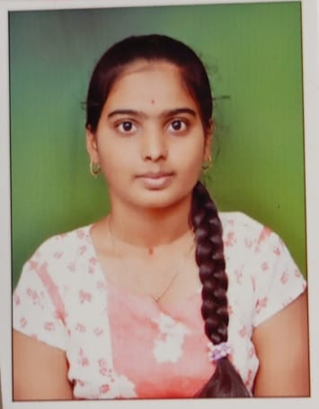

Paste your Photo

**Submitted To**

**Name of the Faculty: MR Rohith M M**

**Designation: Assistant Professor**

**Department of Chemistry**

|  |  |  |  |  |  |
| --- | --- | --- | --- | --- | --- |
| **Assignment** | **Name of the Assignment** | **Submitted Date** | **Maximum Marks** | **Obtained Marks** | **Signature of the Faculty** |
| 1. | 1. Instances of Corrosion and their Remedial Actions 2. Role of Polymer nanocomposites in Hydrogen Production from Challenging Water Sources 3. Environmental Impacts and Benefits of State-of-the-Art Technologies for E-Waste Management |  | **4+3+3 =**  **10** |  |  |
| **2.** | 1. Biosensors and their Widespread Impact on Human Health 2. Recent Advances in Quantum-Dot-Enhanced Liquid-Crystal Displays |  | **5+5 = 10** |  |  |